# Durable Furnitures

Alfonso

## Small Classic Shaker Dinette Set

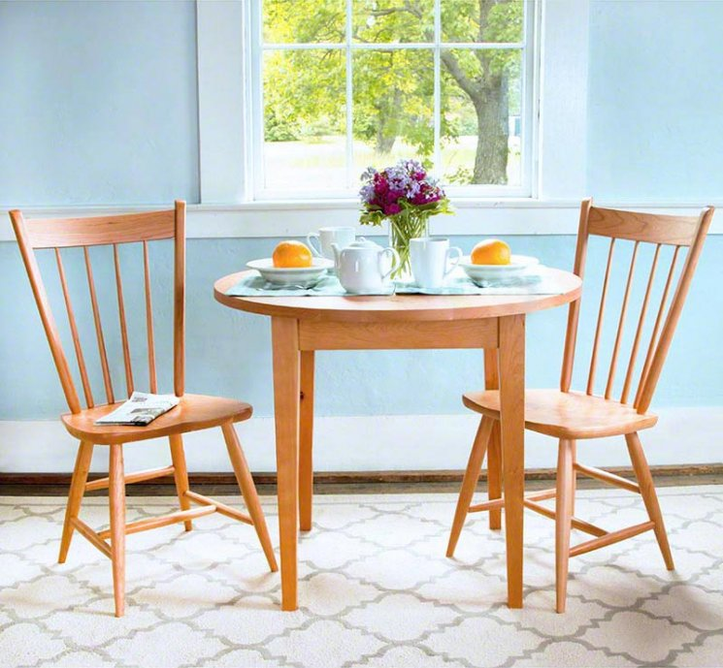

Envision sitting down and enjoying your next meal with our Small Classic Shaker Dinette Set. Traditional style meets compact design in this high-quality dining set. Finely crafted in Vermont using sustainably harvested wood, this set is a great space saver for any kitchen and built to last a lifetime.